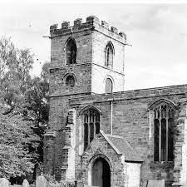

Lambley Parish Council
Application for Interment

To provide the best possible service we ask for all application forms to be received no later than 9:00am 3 working days
before the Interment is due to take place. By agreement we may accept application forms later, provided that we have
accepted the booking and that the application is received electronically. The Certificate of Disposal or Coroners
Certificate can be attached to this form or sent to the Parish Clerk under separate cover.
All costs involved will be invoiced separately by the Parish Clerk

Name, address, email and telephone number of the
Funeral Director
Name of Applicant
Name
Address, including postcode
Telephone
Mobile
Email
Name of the deceased
Full Name
Age at death
Place of death
Date of death
Address
Funeral Arrangements
Plot Number
Deed Reference Number
Is the deceased named on the deed?
Can you provide proof of entitlement?
Interment Date
Time at Graveside
Coffin Type & Size including handles
Name of Minister or other
Have arrangements been made with Nigel Wilf for the plot to  be prepared | YES/NO
Have arrangements been made for the existing headstone to  be removed. | YES/NO
If a service is to be held, please confirm you have made arrangements for this | YES/NO

Please address all correspondence to:
Catriona Saxton - Clerk to Lambley Parish Council
Email: clerk@lambleyparishcouncil.org.uk
Tel: 07982 130173
c/o 24 Kenneth Road, Arnold, Nottingham, NG5 8HY

