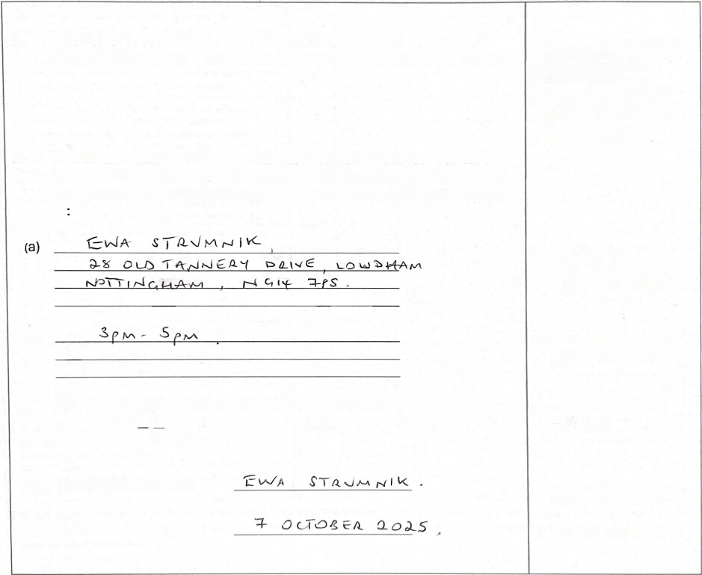

3

**Lambtey Parish Council**

**Notice of conclusion of audit**

**Annual Governance & Accountability Return for the year ended 31 March 2025**

Sections 20(2) and 25 of the Local Audit and Accountability Act 2014

Section 16 of the Accounts and Audit Regulations 2015 (SI 2015/234)

Notes

**1** . **The audit of accounts for Inmbtey Parish Council for the year ended 31** March 2025 has been completed and the accounts have been published.

**This notice and Sections 1** , **2 & 3 of the AGAR must be published by 30 September**. **ThIs must Include pubUeation on the smaller authority’s website**. The smaller **authority must decide how long to publish the Notice** ***toC*** **the AGAR and** ext8rn8t auditor report must be **publicly available for 5 years**.

2. The Annual Governance & Accountability Return including the auditor’s certificate and opinion is available for inspection and copying by any local government elector of the area of **Lambtey Parish Council** on application 10

(a) Insert the name, position and address of the person to whom **local govemmerrt electors should apply to inspect the AGAR**

(b)

3. Copies will be provided to any local government elector of the area on payment of£ I (c) for each copy of the AnnuaIGovernance & Accountability Return.

Announcement made by: (d)

Date of announcement: (e)

**(b) Insert the hours dwing which**

inspection rights may be

exercised

(c) Insert a reasonable sum for copyIng costs

(d) Insert the name and position of

**person placing the notice**

(e) Insert the date of placing of the notice

**www**.**pkf**.**t**.**com**

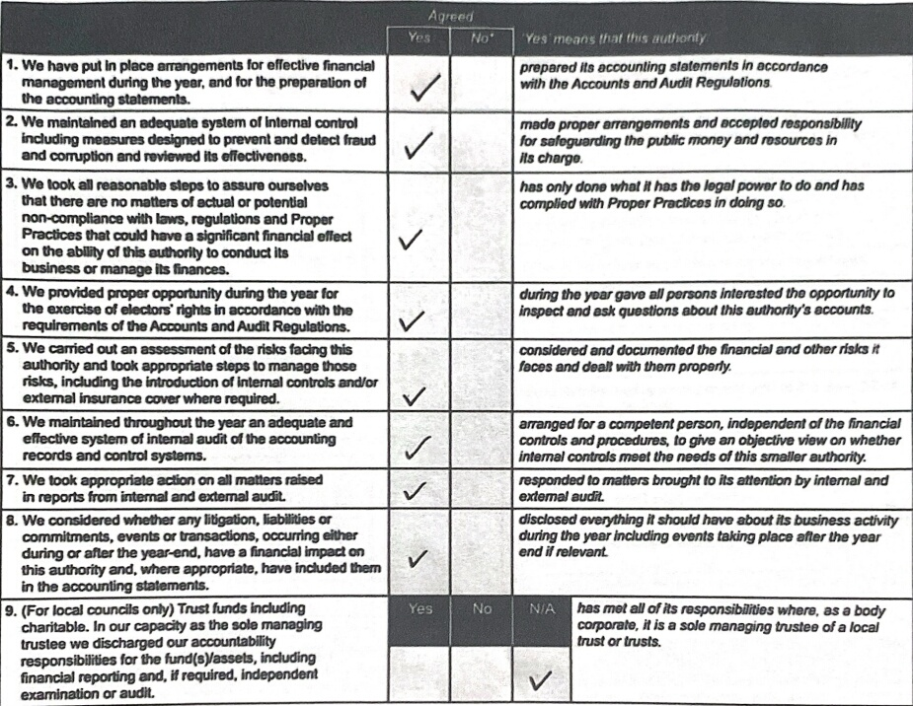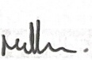

*}\U*

**Section 1** - **Annual Governance Statement 2024/25**

**We achlawledgo as BIO m8mbor5 of**:

**the preparatIon of the AIxx>untlng Statements**. **We oonflnn**, **to the tn8t af our knowledge and beIIef**, **wI#1**

**respect to he Aa~~xxI~~nOng Statements for the year ended 31 March 2025**, **that**

**meetirU af the auttxxtty aI**:

**SIgned by Bn Club and Clark of ho mwOng whBrB**

**and recDrrJOd as minute IBferBnoe**:

**Cl&k**

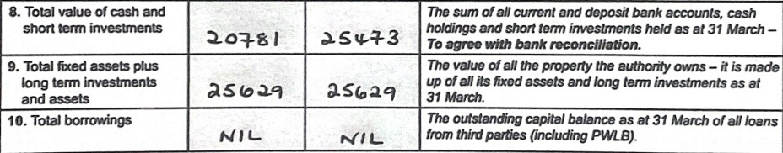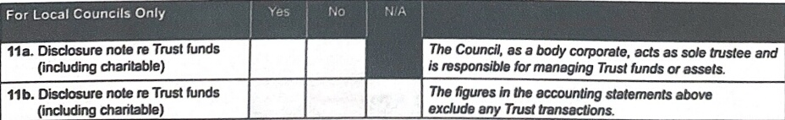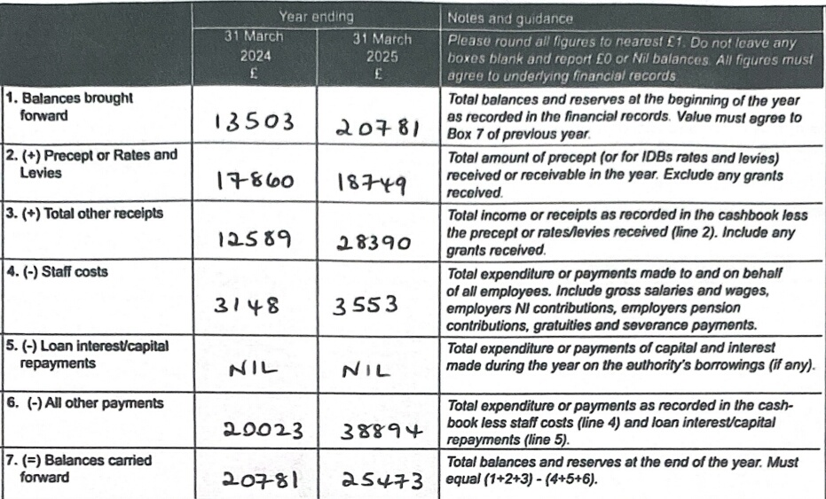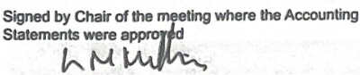

**I**

I

**SectIon 2** - **Accounting Statements 2024/25 for**

**Stat8ments in thIs Annual (Ryv8mann and #kxwnbblltty**

***or*** **Ineomo and expenditure basIs kHkwirtg the ©Iklancn** in

**the financial pcsition of Ihb authority.**

**pr88•nted to the authorIty** ***for*** **approval**

**appraved by thIs authcxity on thIs dab**:

**as reoorded in minute referenae**:

**Date**

|  |  |
| --- | --- |
| 2 External auditor’s limited assurance opinion 2024/25 | |
| **) Mud (Rnnrrnrm arxJ AccourtabHtty Return** (AGAR), in our opinion the **information in Sections 1 and 2 of the AGAR is in accordann with Proper Pracgms arxl no otter matters have come to our** attention giving Gause for conmm that relevant legislation and regulatory requirements have not been met. | |
| The AGAR was not accurately completed before submission *for* review. Please ensure that amendments are corrected in the prior year | |
| **comparattves when completing next year’s AGAR**: | |
| **e** | Unpresented cheques are incorrectly omitted from the bank reconciliation and from expenditure in Section 2. The figures in Boxes 6, 7 and 8 should read £38,**9BI**, £25,419 and £2S,419 respectively, ' |
| **Other matters not affeding our opibon which we draw to tIe atteldicxl of the authority**: | |
| **We note that the smaller authority did not comply with Regulation 15 of the Accounts and Audit Regulations 2015 as it failed to make proper** provision during the year 2025/26-for the exenis6 of publii rights, since the notice regarding the pe-nod for the exercise of public righti wis hot published b–efore-the start of the period, As a result, the smaller authority must answer 'No’ to Assertion 4 of the Annual Govemance **StaGment** ***for*** **2025/26 and ensure th-**a**t it makes proper provision** ***for*** **the exdrcise of public rights durirB 2026/27**. | |
| The smaller authority has not provided an adequate explanation for the variance between the prior and current year values in Box 3 of Section | |
| 2. | |



**Section 3** - **External Auditor’s Report and Certificate 2024/25**

In respetJ of

**Lambley Parish Council** - **NT0107**

1 Respective responsibilities of the auditor and the authority

**Our responsibility as auditors to oomplete a limited assurance review is set out tV the National Audit Office (NAO)**. **A** limited assurance review is **not a full statutory audit**, it does not constitute an audit carried out in accordance wtth Intemational Standards on Auditing (UK & Ireland) and hence it **does not** provide the same level of assurance that such an audit would. The UK Government has determined that a lower level of assurance than that provided by a full statutory audit is appropriate for those local public bodies with the lowest levels of spending

Under a limited assurance review, the auditor is responsIble for reviewing Sections 1 and 2 of the Annual Govemance and Accountability Return in acconianoe with NAO Auditor Guidance Note 02 (AGN 02) as issued by the NAO on behalf of the Comptroller and Auditor General. AGN 02 is available from the **NAO** website – https,//www.nao.org.uk/code-audItpractice/guidance-and-information-for-auditors/

This authority is responsIble for ensuring that its financial management is adequate and effective and that it has a sound system of internal control. The authority prepares an Annual Governance and AccountabIlity Return in accordance with Proper Practices which :

• summarises the accounting records for the year ended 31 March 2025; and

• confirms and provides assurance on those matters that are relevant to our duties and responsibiltties as external auditors.

3 External auditor certificate 2024/25

We cel$N +rat we have completed our review of Sections 1 and 2 of the Annual Governance and Accountability Return1 and discharged our responsibilities under the Local Audit and Accountability Act 2014, for the year ended 31 March 2025

External Auditor Name

**PKF LrrrLEJOHN LLP**

External Auditor Signature

Pg

Date

30/09/2025

mnuil(iovemance arId AccountatiFtty Return 2024/25 Form 3

Local Councils, Internal Drainage Boards and other Smaller Authorities-

Page 6 of 6